Db Migration steps

These below steps are to be performed to migrate Old Db data into new Db.

We need to perform snapshot of old Db:

1. Login into AWS RDS services
2. Select the RDS which we need to migrate.

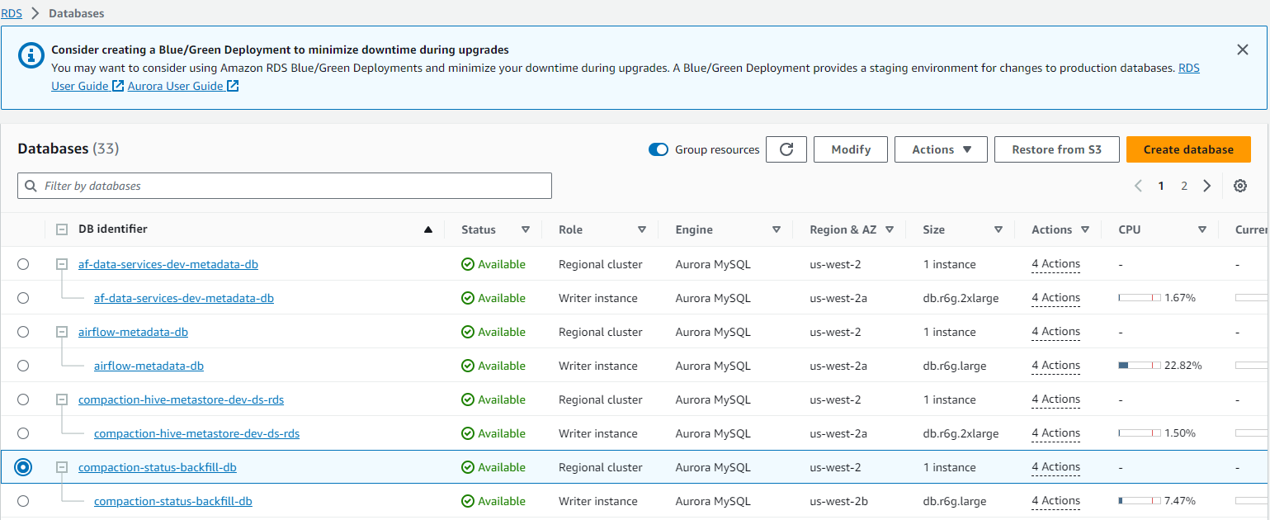

Validating exiting tables and databases of old RDS.

SELECT

   table_schema AS "Database",

   sum(data_length + index_length) / 1024 / 1024 AS "Size in MB"

FROM

   information_schema.tables

GROUP BY

   table_schema;

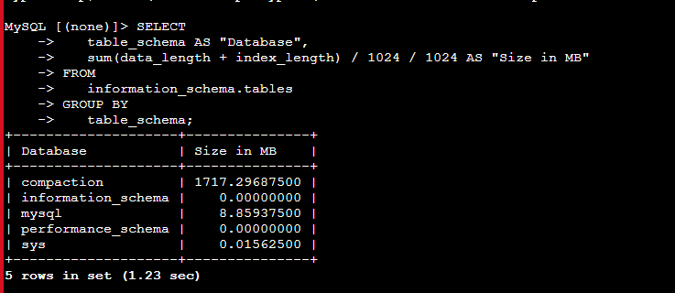

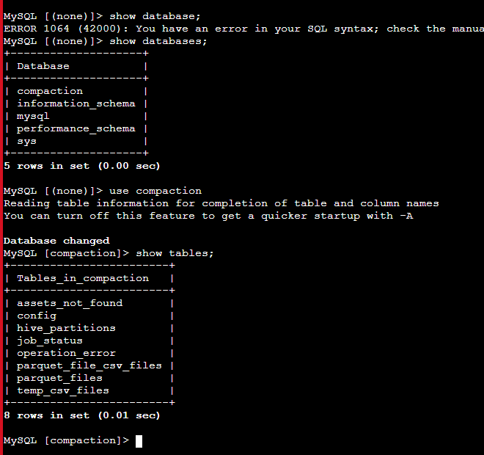

mysqldump compaction assets_not_found config hive_partitions > my_backup.sql

Import and export the backup.

mysql -h compaction-status-backfill-db.cluster-cf5nnjx3u9dx.us-west-2.rds.amazonaws.com -u analytic_status -p mysqldump compaction assets_not_found config hive_partitions > my_backup.sql

MySQL [compaction]> SELECT TABLE_NAME, table_rows, data_length, index_length, round(((data_length + index_length) / 1024 /1024 / 1024),2) "Size in GB" FROM information_schema.TABLES WHERE table_schema = "compaction" ORDER BY (data_length + index_length) DESC;

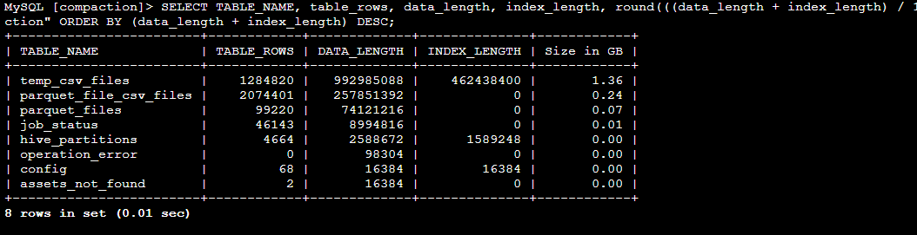

Dbbackup dump cmds:

mysqldump -u analytic_status -h compaction-status-backfill-db.cluster-cf5nnjx3u9dx.us-west-2.rds.amazonaws.com -p compaction hive_partitions > table_name.sql



Upload to s3



Download to other instance to

New RDS:-

compaction-status-db

mysql -h compaction-status-db.cluster-cf5nnjx3u9dx.us-west-2.rds.amazonaws.com -u compaction_status -p

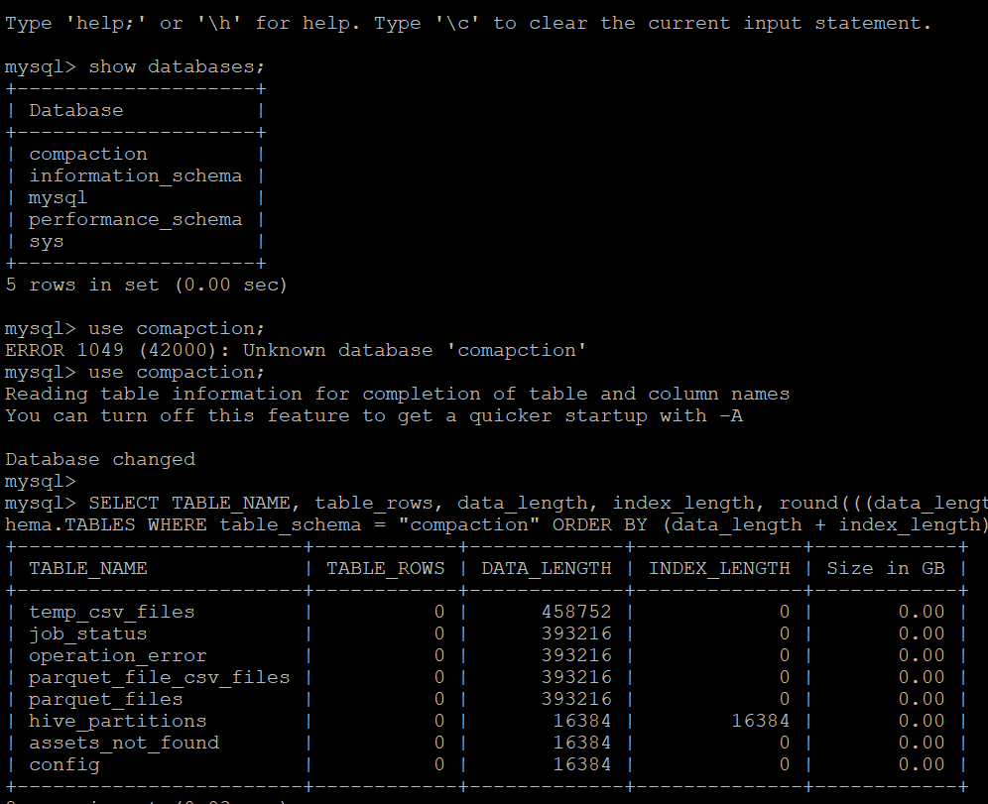

Old db rows

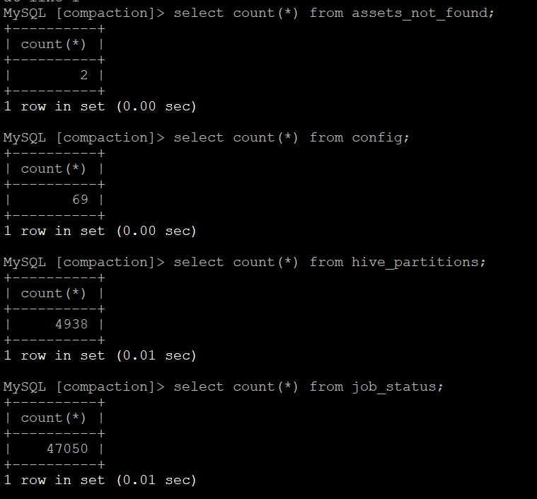

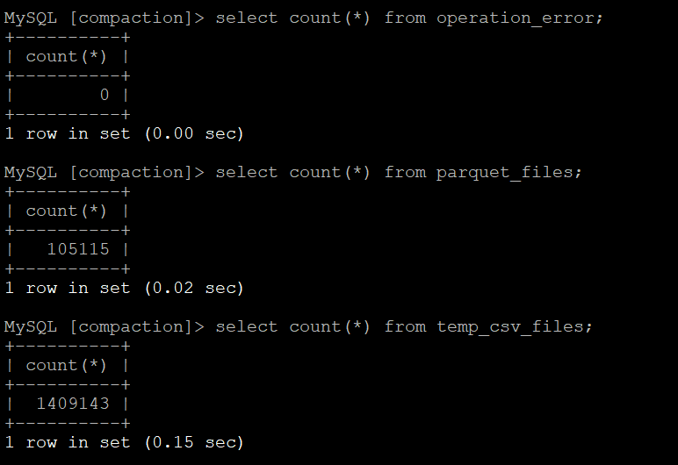

analyze table compaction.temp_csv_files;

primary id should match and in dest, insert a record and notice the primary we should not specify primary key.